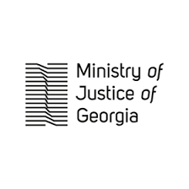

Meeting of the Inter-Agency Coordinating Council for Combating Drug Abuse
14 May 2019
Agenda

17:00 – 17:10 Opening Remarks
Deputy Minister of Justice of Georgia/Acting Chairperson of the Council, Mr Gocha Lordkipanidze

17:10 – 17:30 Presentation of the Draft Anti-Drug Action Plan for 2019-2020
Head of the Public International Law Department of the Ministry of Justice/ Secretary of the Inter-Agency Coordinating Council for Combating Drug Abuse, Ms Ketevan Sarajishvili
17:30 – 18:00 Discussion and Adoption of the Anti-Drug Action Plan for 2019-2020
18:00 – 18:15 Closing Remarks
Deputy Minister of Justice of Georgia/Acting Chairperson of the Council, Mr Gocha Lordkipanidze

